EXPERIMENT 5 B

DATA VISUALIZATION USING MATPLOTLIB

Aim
To create and analyze different visualizations such as line charts, bar charts, pie charts, histograms, scatter plots, and box plots using the patient dataset.

Algorithm 1 – Line Chart
Step 1 Import Matplotlib and Pandas.
Step 2 Load dataset.
Step 3 Select data.
Step 4 Use plot() function.
Step 5 Display chart.

Program 1 – Age Trend
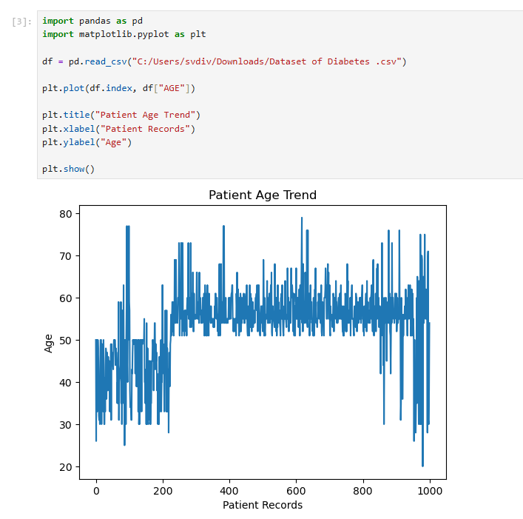

Algorithm 2 – Bar Chart
Step 1 Select categorical data.
Step 2 Count the values.
Step 3 Use bar() function.
Step 4 Display chart.

Program 2 – Gender Distribution

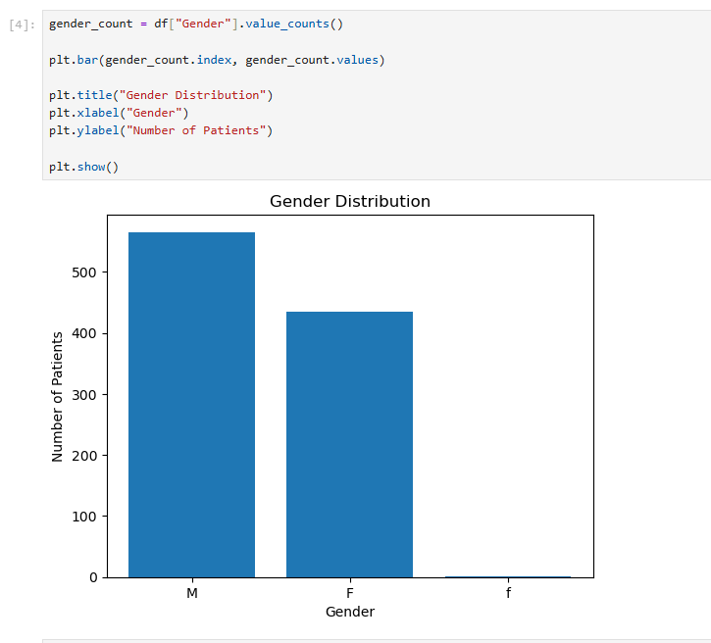

Algorithm 3 – Pie Chart
Step 1 Select categorical data.
Step 2 Count categories.
Step 3 Apply pie() function.
Step 4 Display chart.

Program 3 – CLASS Distribution

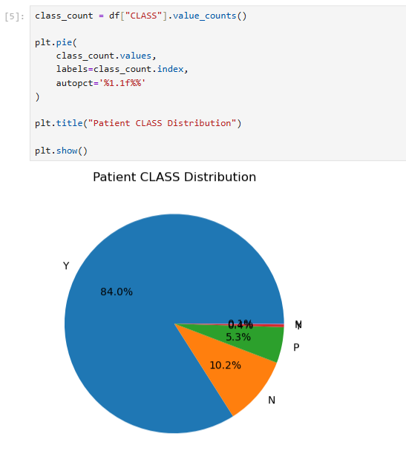

Algorithm 4 – Histogram
Step 1 Select numerical data.
Step 2 Use hist() function.
Step 3 Add labels.
Step 4 Display chart.

Program 4 – HbA1c Distribution

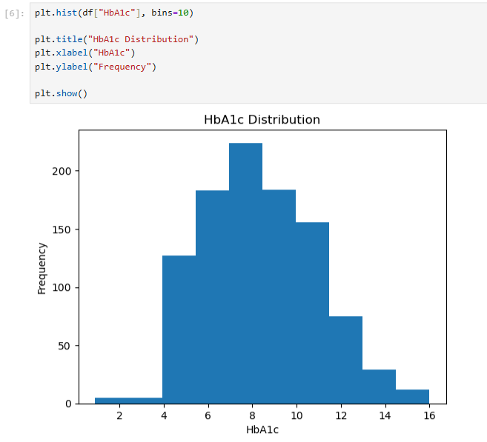

Algorithm 5 – Scatter Plot
Step 1 Select two numerical variables.
Step 2 Use scatter() function.
Step 3 Add labels.
Step 4 Display chart.

Program 5 – Age vs BMI
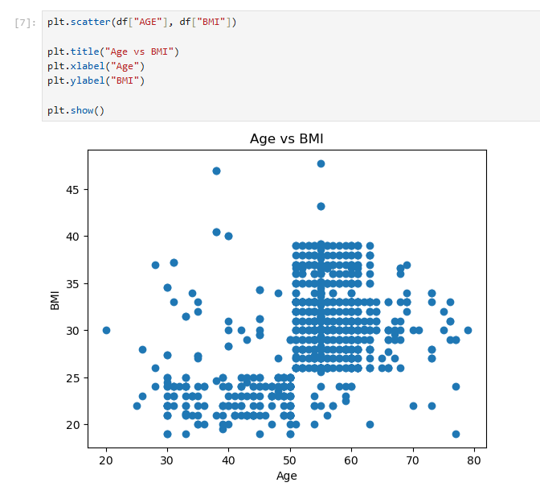

Algorithm 6 – Box Plot
Step 1 Select numerical data.
Step 2 Use boxplot() function.
Step 3 Display chart.

Program 6 – BMI Outliers
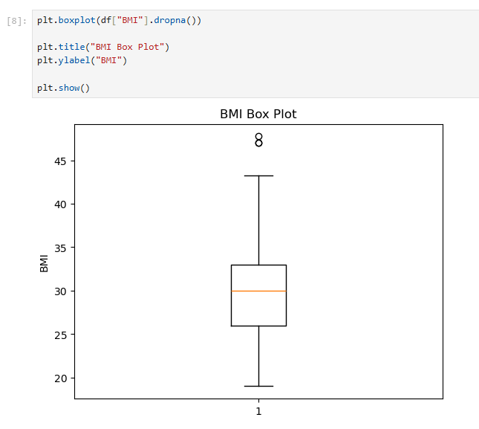

Algorithm 7 – Multiple Line Charts
Step 1 Select two numerical datasets.
Step 2 Plot both datasets.
Step 3 Add legend.
Step 4 Display chart.

Program 7 – Cholesterol and Triglycerides

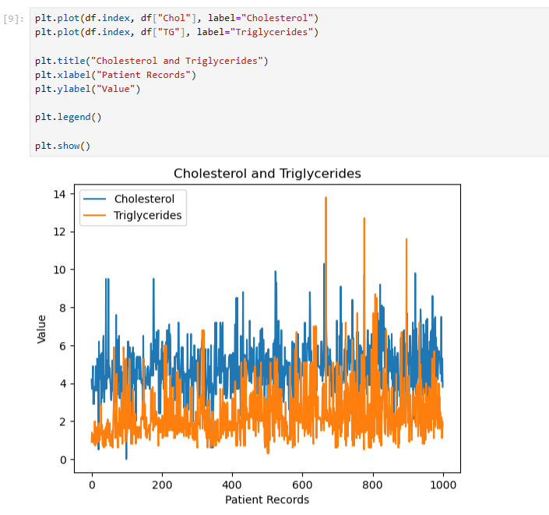

Result
Thus, various data visualizations were successfully created using Matplotlib to analyze the patient dataset and understand its trends, distributions, relationships, and outliers.

